|  |
| --- |
| STAGE 1: DESIGN DOCUMENT |
| FX Problem - Design Document |
| Innovation Hack! |
|  |
| **TEAM:** One man Army :P |
| **AMBAREESH REVANUR**  ambareesh.r@gmail.com  (+91) 9916-084-938  @revanurambareesh/forexInsights |
|  |

**Overview**

This project aims to support forex business using data available on public web domain using NLP and web-scraping. A set of most frequently appearing *keywords* are used as feature set. The dataset is generated for each of the entry given in excel sheet (problem statement) using web search APIs and each link is scraped for data within specified HTML tags. The presence of the keyword in the data, is considered as *y* = 1 or positive case, after processing for its presence in majority of the links crawled by search engine. Once the dataset is ready, Naïve Bayes modeling is performed. This model is used to predict the probability to determine a **potential FX customer**. An intuitive GUI is provided for this project. Complete project is developed in Python 2.7. This multi-threaded tool provides complete solution to the forex problem.

Design Document is uploaded in git repository/Stage 1 Documents/FX Problem.pdf

**Table of Contents**

Introduction 3

Tools and Technology 3

Feature Selection 3

My solution: Algorithm 3

Code analysis 3

Other features 3

Results 4

Future scope 4

Publication references 4

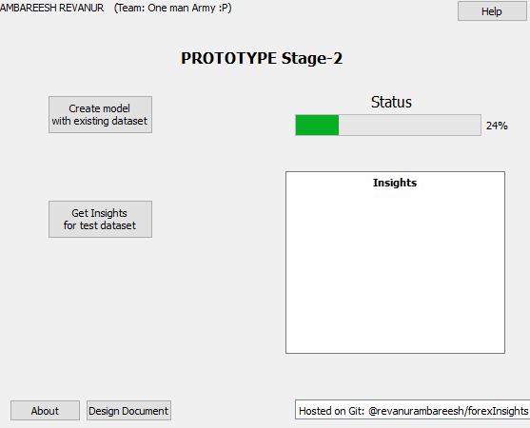

Figure : Stage 2 Prototype GUI

# Introduction

Machine Learning is science of predicting required parameter without have the computer program explicitly coded for so. This is possible by learning, what is called a ‘model’, for the collected data and, based on the nature and interrelationship of the data prediction can be made for an unknown parameter.

Machine Learning is gaining prominence due to large availability of data. Machine Learning’s philosophy centrally lies around the fact that more the genuine data available, better is the model learnt, and hence the accuracy of such a model is high.

Web technology has developed has seen boom in recent years with development of higher compute power and cheaper storage materials and tools available for the same. Lots of information is available on internet. According to recently released *voucherCloud* survey, 25,000GB of data is being uploaded per second to the internet. That is huge number. With this amount of data being available at finger-tips, it is possible to get useful information for just about anything.

In order to use the data already present on the web, two techniques are generally used, web-crawling and web-scraping. A web-crawler (sometimes referred to as web-spider) is a internet-bot that visits each allowed end-points systematically on the web for indexing the page. But web-scraper on the other hand, accesses data of the web for specific reasons including data mining, computer vision, machine learning and NLP.

In this project, data is scraped from across the web from various sources for forex and non-forex classes as per the given guidelines and is stored for learning a machine learning model. In this document following conventions are used frequently:

: Dataset created from web

: The label assigned with **1** as Forex-Class and **0** as Non-Forex Class

## Scope

This document gives a complete picture of the algorithm, code, folder structure and also some of the NLP research papers referred for this project. The software developed (herein referred to as “**forexTool**”) will scrape the data from internet, generate definitions, and creates a machine learning model. This model can be used to derive useful insights like:

* If the company is likely to opt for Forex or not
* How the model predicted the above

This tool is a prototype and offers solution to the stated problem statement.

## Overview

This document is organized into:

* Section 1: System overview
* Section 2: Software development tools
* Section 3: Machine learning model
* Section 4: Solution approach
* Section 5: Relevant code snippets
  + Data generation
  + Insight generation
* Section 6: Tool features
* Section 7: Results & Future scope
* Section 8: References

# Section 1: System overview

There are 5 major components in the tool:

1. Web-Scraper
2. User-Interface (UI)
3. NLP based keyword analysis
4. Machine Learning model
5. Web-Search

Fig. 2 shows how each of the above components interacts:-

* Web scraping is performed based on the top web-search results as generated by Google™ Search results. Generally top 10 search web-results are scraped.
* The data obtained through web scraping is stored into file database (hardisk).
* Based on the data a machine learning model is created with:
  + Training Phase
    - Features: *keyword*s describing the word ‘Forex’ on few popular internet pages. (here the word ‘popular’ refers to the top Google™ Search results)
      * In this project about ~200 *keywords* have been extracted from internet pages. Each of these *keywords* is used as feature. (Keyword extraction is explained in further sections)
      * For **example**, if ‘billion’, ‘mumbai’, ‘tax’ are 3 keywords and if the word ‘billion’ is present in a piece of text in the dataset, then a label is assigned to the piece of text. If the word is not present, then a label is assigned to it.

More concretely, it can be defined mathematically as follows:

* + - * be the dataset with a mapping , where, with indicating absence of keyword in majority of web-scraped internet pages and indicating the presence of keyword in majority of web-scraped internet pages for record in dataset used for training. is the mapping. The machine learning algorithm tries to learn a new function or that tries to minimize the error of prediction.
      * Note: In this project top 10 Google™ Search results are generally scraped. Therefore majority generally indicates appearance of the keyword in 5 scraped web-pages.

More details have been discussed in further sections

* + - Label : As already stated if record is forex company, then or else .
  + Test Phase
    - During this phase, prediction is made to a new (not foreseen by model) company. This is done by
      * Top 10 (generally 10) Google™ Search results are retrieved.
      * These results are scraped by a spider
      * In the retrieved results, the *keyword*s are looked up. If a particular *keyword* is present in majority of the results, then corresponding feature value is 1. Otherwise the feature value is 0.
      * If , then the company is likely to opt for Forex option, else then the company is not likely to opt for Forex option.
* User Interface (Fig. 1) is depicts the available functionalities.

The following diagram shows the interaction of components. Web-Search component takes input as the file containing list of Forex and Non-Forex companies. For each company it retrieves the top 10 (generally 10) search results and stores them as links.txt file. Web-Scraping component reads this file and scraps for data in each of the URLs in the links.txt file. For every link, a text file containing the scraped data is stored.

Now a model is learnt as described. If majority of the text files (belonging to a single company), has a given word, the feature value corresponding to it is .

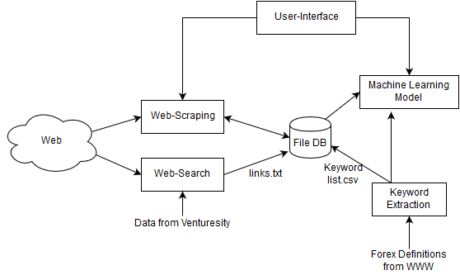

Figure : System architecture

# Section 2: Software Development Tools

This project requires use of many features including graphical user interface. Python has been chosen as the coding because of its simplicity and yet provides robust debugging options and library function calls.

The application was built and tested in Windows™ 10.

## Python

Many high-level and low-level applications have been implemented in past with Python because it gives the programmer all flexibility one needs to quickly develop, debug and test the software. In this project **Python 2.7** version 2.7.12 has been used. JetBrains™ PyCharm (v2016.1.4) has been used for development.

Each of the components (as described in previous section) requires multiple packages and APIs. Some of the most important modules heavily used in this project have been described below:-

### Google Custom Search API

Web-Search component makes use of this API provided by Google™. It is one of the most reliable web-crawler and search-engine. This has been used to retrieve the information from the web.

Here are some the technical details of the API:

* Responds in JSON. (a python package by name ‘json’ is required)
* Requires API key and custom search engine key.
* It uses httplib2 and uritemplate python packages.
* Search results returned are 10 by default. The search results can be made to request according to relevance or according to recent date of upload.

The following python statement is mandatory for this tool to run:

$> from googleapiclient.discovery import build

The module build contains all the custom commands that can be used by the programmer for getting the search results with various parameters.

There is another python package ‘pprint’ used to format the print on terminal.

The python package (Google™ Custom Search engine) is stored within the project repository and the functions are used to get 10 top results. However, in few cases where the search query is not popular, only about 4 to 6 results are retrieved. Since the algorithm uses majority-criterion to decide the value of feature, number of results will not affect too much.

### Scrapy

Web-Scraping is another important component of the tool. The dataset required for the machine learning algorithm is generated by using a python package called Scrapy. As per the official documentation Scrapy is an open source and collaborative framework for *extracting the data* you need from websites in a fast, simple, yet extensible way.

In this project, the data is extracted using Scrapy v1.3.0. The spider is defined and a function, parse() is defined such that it stores the data retrieved from the web in txt files for each of the link which is used as dataset for learning machine learning model.

The implementation of the spider using Scrapy is dealt with in Section 5.

Technical details:

* By default Scrapy can traverse the all the a:hrefs of a given page as limit is not imposed. i.e. DEPTH_LIMIT = 0 by default in setting.py file.
* The Scrapy makes use of a special asynchronous I/O and events of Twisted-Internet API. This API offers a special web-scraping engine platform called reactor which provides APIs for networking, threading, dispatching events, amongst others.
* Scrapy offers two methods for web-scraping using a python script. They are CrawlerProcess and CrawlerRunner. In this project, CrawlerRunner has been used as it provides flexibility to control the number of links a spider can crawl and also serial execution that provides helps in debugging the code.

### RAKE (Rapid Automatic Keyword Extractor)

This is a NLP based tool. Python implementation of the Rapid Automatic Keyword Extraction (RAKE) algorithm as described in (Rose, S. et. al, 2010). In this chapter of the book, authors have described an algorithm called ‘RAKE’ : Rapid Automatic Keyword Extractor. Keywords represent essence of the text material and has been used as described in previous sections.

Details of the thorough implementation of RAKE algorithm is out of scope of this document and should be referred appropriately for detailed knowledge. Basically, identifies all possible candidate keys, after which a score is assigned to each of the keyword based on degree and frequency of word vertices in a graph. It should be noted that candidate keyword is decided using a list called “stoplist”.

### Qt

Qt (pronounced “cute”) is a python framework used for development of Graphical User Interface (GUI). The UI is designed using Qt designer. The Qt designer produces a *.ui file which is converted to a python script using the command at command prompt-

$ >> PYTHON_ROOT\...\PyQt4\pyuic4.bat -x file.ui -o FXfront.py

# Section 3: Machine Learning model

In this project, features are the presence (or absence) of keyword from the data scraped from majority of top web search results. Hence and both take values from .

Formulating the problem, dataset available is X and is supervised with y. When a new x’ (company feature vector), the model must assign a value in {0, 1} that indicates the opting possibility of the company in question.

The algorithm chosen for this purpose is ‘Naïve Bayes’. It makes an assumption the independence of occurrence of the keywords in the results-set of the company. From Bayes theorem,

Where can be considered Guassian likelihood.

### SCIKIT

Scikit-Learn is a machine learning library tool available for python. In this project, Naïve Bayes classification algorithm is used as described with scikit-learn. Forex company has been labeled 1 and non-Forex as 0.

clf = GaussianNB()

clf.fit(X, y)

The above statements describe how a model is trained in scikit. Training and testing a model is Scikit-learn package is as simple as described by the above statements.

In order to avoid overfitting, the keywords have been chosen independent of the Forex & Non-forex company.

# Section 4: Algorithm

The tool has 3 major functionalities:

* F1: Scraping data from internet
* F2: Training data with existing/scraped dataset
* F3: Using the trained model, making a prediction for new company.

Each of the above functionalities F1-F3 is executed as described in following algorithms.

### F1: Scraping the data from internet

Step **1**: Reading the data provided in the dataset (from Venturesity)

Step **2**: For a record, obtain Google™ search results using GoogleCSE API. Parse the JSON response obtained from the GoogleCSE API and obtain the URLs obtained from a specific tag called URL.

Step **3**: In data/train_data/ create a new folder with label () and company name. Store all the retrieved results as links.txt file in the folder.

Repeat step 2 – step 3 for all the records in the dataset file.

Step **4**: From each of the folder, get the links, and web-scrape using Scrapy with initial start_url path as these URLs. For each URL in the links.txt, scrape the HTML <body> tag for text fields with XPath as //body/descendant-or-self::*/text(). The results are stored in .txt file located within the folder belonging to the company. See forexInsights/data/train_data/ for clarity.

This step ends the F1-algorithm.

### F2: Training model with scraped dataset

Step **1**: For every company in the dataset,

## Project structure organization

Project folder is organized according to different components.

* /data/ folder contains all the data collected from the internet, machine learning model, keywords for classification.
  + train_data/ contains all the scraped data
  + model/ contains the naïve bayes machine learning model
  + dataset_axis.csv contains the input data from Venturesity
* /model/ folder contains the code required to generate machine learning model
* /scraper/ folder contains the web-scraper and Google™ custom search engine code.
* /UI/ folder contains the code for rendering UI
* Project can run by, (in command prompt)

>> python main.py

# Code analysis

## Demonstration

# Other features

* Changing defining words may improve results.
* Multithreading
* This project uses Scrapy 1.3.0 which respects *robots.txt*.
  + As defined in settings/settings.py => ROBOTSTXT_OBEY = True

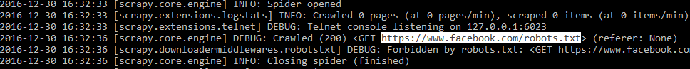

Figure : Scrapy bot obeys Robots.txt

# Results

# Future scope

Following ways or approaches may improve the results significantly.

* Data collected can be more formatted.
* Some of the keywords that do not play any role in machine learning model may be removed or manually replaced with better ones.
* Definitions can be learnt for both Forex and non-Forex company and hence better chance that prediction learns to get higher margins for the training classes in feature space.

# Publication references

[1] Rose, S., Engel, D., Cramer, N., & Cowley, W. (2010). Automatic Keyword Extraction from Individual Documents. M. W. Berry & J. Kogan (Eds.), *Text Mining: Theory and Applications*: John Wiley & Sons.

[2] Pedregosa, Fabian, et al. "Scikit-learn: Machine learning in Python." *Journal of Machine Learning Research* 12.Oct (2011): 2825-2830.

### About Me: AMBAREESH REVANUR

I am currently pursuing B.E. degree 3rd year, CSE at R. V. College of Engineering. I had obtained CET rank of 46 out of 0.1M competitors. I have closely worked with both industries and academia to solve real world, societal and business problems using technological solution.

At R&D labs of CSE Dept of RVCE, I developed a Textile image processing tool with C#.NET which is now used by about 100 weavers. Also, I have worked on challenging computer vision problems like Underwater Object Tracking using machine learning and published some of my work in conferences (using ML and CV).

At Siemens Healthcare Pvt Ltd, I have worked on an internal security tool called Security Vulnerability Monitoring (SVM) Tool. SVM automates vulnerability monitoring for many of the Syngo products (Core Siemens HC medical system) and provides a robust solution to protection of their product against vulnerabilities of the code.

In my free time, I compete and participate in Hackathons. I am an active member of IEEE Society. I have helped Team Chimera, RVCE, build web-interface and website.

Feel free to reach me at, ☺

 [@revanurambareesh](https://github.com/revanurambareesh)

 <https://in.linkedin.com/in/ambareeshr>